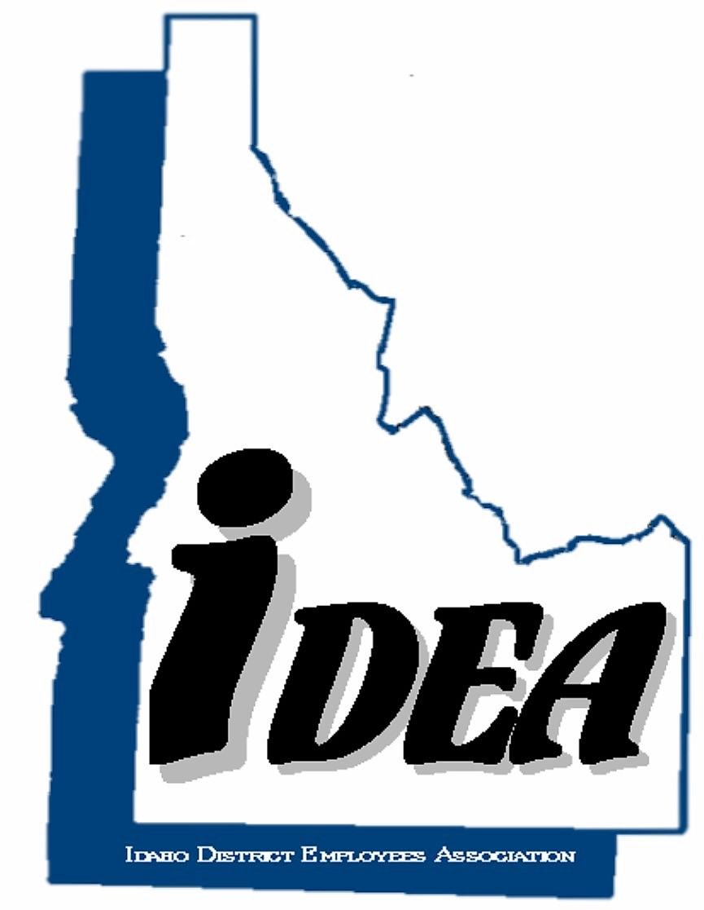

Idaho District Employee Association
Directors Meeting
Tuesday, November 15, 2022- 10:00 to 11:30 am
Best Western, Burley, Idaho

Call Meeting to Order
Welcome and Roll Call – Robbie Taylor
Minutes of Previous June 15, 2022 Directors Meeting - Joyce Smith
(Action Item: review and approve)
Financial Reports – Robbie Taylor
  - Financial report (Action Item: review and approve)
  - 2022 Dues (information only)
  - CY-22 Budget vs. Actual (Action Item: review and approve)
  - Proposed Budget for CY-2023 (information only)
IDEA Lunch meeting review:
IDEA Business and Review for IDEA Meeting and Luncheon:
  - IDEA Directors Meetings Schedule for 2023 Directors (information only)
  - IDEA Performance Report, who will to do it? (information only)
  - IDEA Officers election for 2023 (Action Item: review and approve)
IDEA Workshop from 2:00 pm to 4:00 pm – Directors and membership
Adjournment (Action Item: Approve)

